Code Jumper L. 9-10

PART 1:

- Selection and Merge Pod: https://www.youtube.com/watch?v=Lx7EnNcjUrU
- KEY VOCABULARY
• Selection: A structure in computer programming where, if a question is asked, the program decides what to do next based upon the answer. This is sometimes referred to as an if-then-else statement
. • Conditionals: Statements that run only under certain conditions. For instance, if condition A is true, then perform this specific action.
- Instruct students that once they are standing, they will remain standing if the next question applies to them, but if it does not apply to them then they need to sit back down in their chair.
  - Ask the following questions (feel free to add more questions or tailor the questions to your own class): • Do you have tennis shoes on? Clap your hands and stand up. • Do you like to eat bananas? Clap your hands and stand up. • Have you ever lost a tooth at school? Clap your hands and stand up. • Have you ever been on a bus ride? Clap your hands and stand up. • Do you have a pet? Clap your hands and stand up. • Do you like to code? Clap your hands and stand up.
- After the activity, ask all students to sit down in their chairs and discuss what they observed when the answer to a question was true and what they observed when the answer to a question was false. (Goal: Students will correlate that when the answer was true, they stood up and clapped, and when the answer was false they sat down and remained quiet.

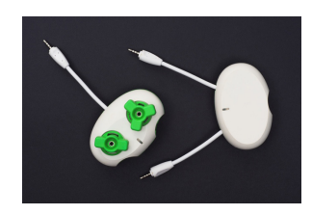

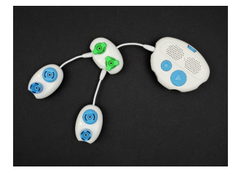
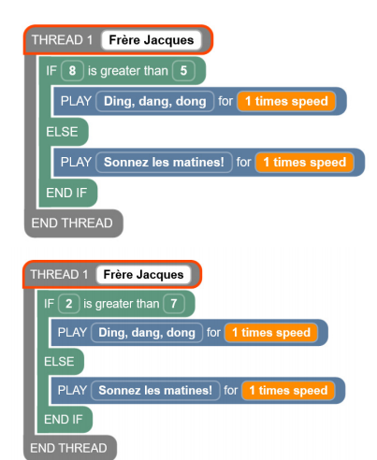
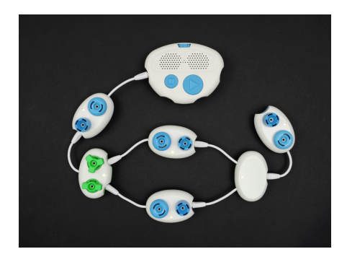

PART 3:
- STUDENT CODE CARDS
- Helen’s Story
• Sound Set: Helen’s Story THREAD 1 STORY PLAY Helen is looking for her friends for 1 times speed
~
~PLAY Haunted house for 1 times speed
~PLAY She opens the door for 1 times speed
IF 2>7
~PLAY Her friends jump out and yell surprise! for 1 times speed
~ELSE PLAY She sees a ghost and screams! for 1 times speed
END IF END THREAD

