Code Jumper L. 2, 3, 4

PART 1

- Set up a line of chairs (one for each student).
- Ask the students to think about what they do in the morning to get ready for school. Possible steps could be: • Wake up • Brush teeth • Get dressed • Comb hair • Eat breakfast • Take the bus to school
- Explain that an algorithm is “a step-by-step process to complete a task”. A simpler way of saying this for younger students is to describe it as “a list of steps to complete a task”.

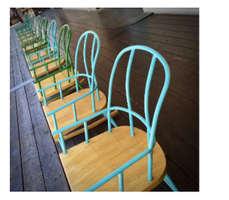

PART 2
- Explain that a parameter in computer science is a value that is given as an instruction or command. (Example: Which sound to play or how long to play the sound.)
  - Link to parameter Cards
- Have kids line up around the room, and hand out cards. Explain that the parameters are set on the front (animal sound) and on the back (pitch). We will run the algorithm all in one continuous play.

PART 3
- Explain that a thread is a single line of commands and that in this activity students are going to perform two separate threads at the same time.
- Code Jumper:
  - Start off with this code on one thread-Try to play Twinkle Twinkle
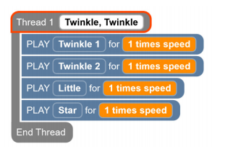
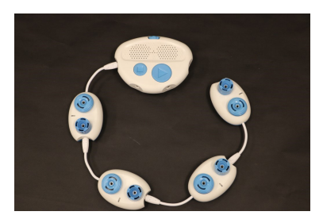
- Loop Pod: https://www.youtube.com/ watch?v=EFKbKLlD3HI
- A loop is a repetition of a series of commands within a sequence
- Review the Loop pod and Loop function, reminding students that the shorter cord is for the main program and the longer cord is part of the loop.

TRY THIS:

