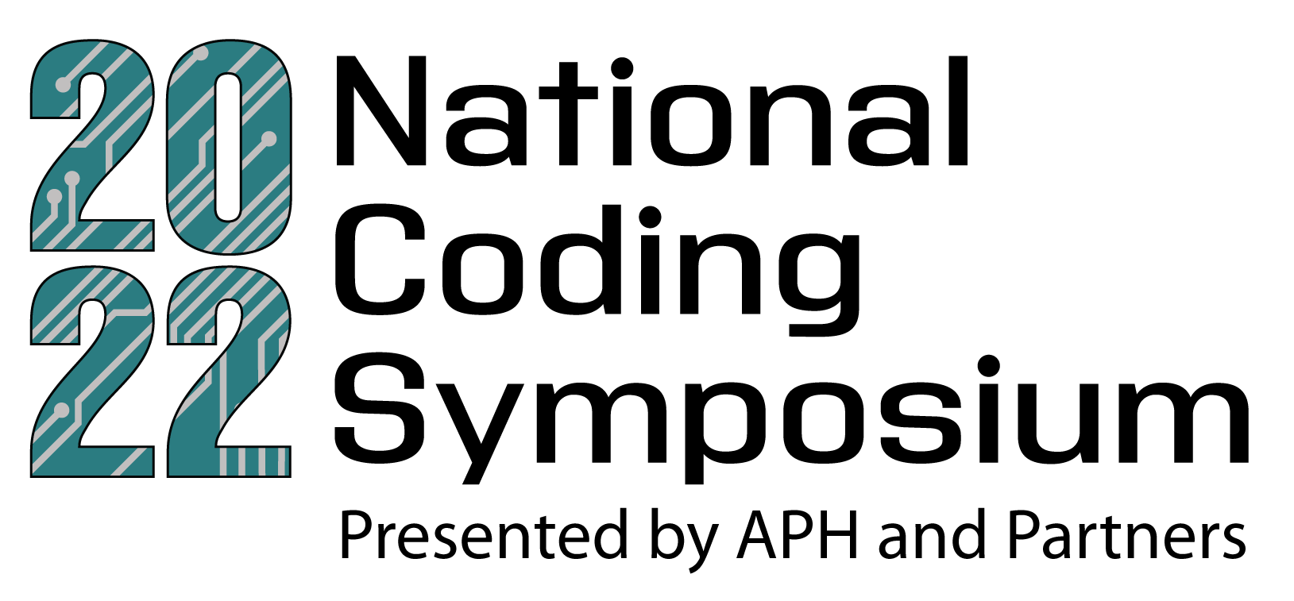

Hosting any pre-symposium coding activity for your students? Excited about the Coding Symposium and want to get the word out to your community? This quick guide gives you key event information, the schedule at a glance, and ideas for how to spread the word so that students all over the world get a chance to attend.

About the National Coding Symposium:
The 2022 National Coding Symposium, hosted by APH and partners, is back for the second year of coding fun and information! Our goal is to make the connections between students, teachers, and professionals in coding from LinkedIn, Vispero, Amazon, NVDA, Yahoo, to share ideas and activities, resources, and career opportunities. Find more details on who should attend and what to expect on our National ConnectCenter Coding Symposium website!
There will be award and scholarship opportunities this year! Check out the Awards page for more information on the drawing. Go to the Scholarships page for information on how to apply.

Dates: May 9 – 13, 2022

Schedule at a Glance:
Hours: 11:30 a.m. – 3:00 p.m. EST (8:30 a.m. – 12:00 p.m. PST)
- Day 1 - Code Jumper and Code Quest; Skill level: Beginner
- Day 2 - HTML; Skill level: Intermediate
- Day 3 - Quorum; Skill level: Intermediate
- Day 4 - Python; Skill level: Advanced
- Day 5 - Career day
See the full agenda for further details.

Pre-Symposium Activities:
This year, we are partnering with student and teacher sites across the country to share activities and experiences with our virtual attendees. You and your students can do the activities in advance too! They are available on the Resources page.

Help Get the Word Out!
Doing a pre-symposium activity with your students? Planning to attend the symposium and want to tell your peers? Use email and social media to help spread the word about the National Coding Symposium and the doors that coding opens for students who are blind and visually impaired!
Don’t forget to download the event logo. Our recommended alt text is: 2022 National Coding Symposium logo. The numbers “2022” are teal and have a gray circuit board pattern across them. Text below reads “Presented by APH and Partners. May 9-13, 2022. aphconnectcenter.org/coding”

Email

Send it to…
You can get the word out by emailing:
- Educators/education professionals
- Parents
- Organizations you belong to
- And anyone interested in supporting coding education for students!

What to Say
Here is some sample email language. Feel free to personalize the messages and share with your community to get people excited for the symposium and related activities!
- Sample Email #1: [subject] Join us for a student coding activity at/in [location]
[body] Empower students of all ages through code education! Leading up to the 2022 virtual National Coding Symposium, our [name of institution/group] is hosting a coding activity to get students excited to explore the field of coding. [Follow with details about your event]

We hope you’ll join us for our event and attend the 2022 National Coding Symposium, May 9-13, to learn how the world of coding, programming, and related careers are available and accessible to students who are blind and visually impaired. Register today!

- Sample Email #2: [subject] Second Annual National Coding Symposium
[body] You’re invited! The 2022 virtual National Coding Symposium from takes place Monday, May 9 through Friday, May 13 to demonstrate how the world of coding, programming, and related careers are available and accessible to students who are blind and visually impaired. Read our blog to learn more about this free virtual event, and get registered today!

- Sample Email #3: [subject] 2022 National Coding Symposium: At a Glance
[body] From May 9-13, the 2022 National Coding Symposium is connecting students, parents, and teachers with professionals in the coding industry! Join us for an impressive list of keynote speakers, panel discussions, presentations, and question and answer sessions to learn about the various pathways to careers in coding for those who are blind or visually impaired! Learn more and register here.
- Sample Email #4: [subject] It’s not Too Late to Register for the 2022 National Coding Symposium
[body] Have you registered for the free, virtual 2022 National Coding Symposium from May 9-13? Join us and our impressive list of speakers and panelists to learn how the world of coding, programming, and related careers are available and accessible to students who are blind and visually impaired. Register today!

The 2022 National Coding Symposium is connecting students with visual impairments, parents, and teachers with professionals in the coding industry! Through a series of speakers, panel discussions, presentations, and question-and-answer sessions, attendees will learn about the various pathways to careers in and/or related to coding. Read our blog to learn more about this free virtual event and get registered today!

Social Media
Feel free to tag us and be sure to use the hashtag #CodingSymposium22 and link to the website so others can access the registration page and resources: https://aphconnectcenter.org/coding/

Where to Post
You can connect through social using:
- Facebook- Share as yourself, as your school, or into appropriate Facebook Groups
- Twitter- Be sure to use the hashtag to connect with other attendees
- Instagram- Post about your classroom’s coding journey
- LinkedIn- Let other professionals know about the importance of coding education for students

What to Say
Here are some sample posts. Feel free to personalize the messages and share with your social network to get people excited for the symposium!
- Sample #1: Coding is for everyone! Did you know that a career in coding is accessible to students with visual impairments? Check out the virtual National Coding Symposium May 9-13 to learn more: https://aphconnectcenter.org/coding/ #CodingSymposium22

- Sample #2: (I/My students/My child) will be attending the virtual 2022 National Coding Symposium May 9-13! Will you? Find out why coding education is important, fun, and not as intimidating as you might think: https://aphconnectcenter.org/coding/ #CodingSymposium22

- Sample #3: Let’s empower the next generation by teaching students with visual impairments about coding! From basic concepts for beginners through transition into a career, the virtual National Coding Symposium (May 9-13) is for students, parents, and educators to learn from amazing keynote speakers, presentations, panels, and Q&A sessions. Learn more: https://aphconnectcenter.org/coding/ #CodingSymposium22

- Sample #4: My students are learning important skills for lifelong success through coding! From computational thinking to debugging and collaborating, students with visual impairments are getting a jump start on meaningful careers at the virtual National Coding Symposium May 9-13. You should too! Learn more: https://aphconnectcenter.org/coding/ #CodingSymposium22

